OPTION 1 (animal life span information):

<https://genomics.senescence.info/species/index.html> : animal aging and life history website

<https://genomics.senescence.info/species/dataset.zip> (anage_data IN THE GOOGLE DRIVE) gives the animal dataset from ^ website

Data headers look like:

HAGRID Kingdom Phylum Class Order Family Genus Species Common name Female maturity (days) Male maturity (days) Gestation/Incubation (days) Weaning (days) Litter/Clutch size Litters/Clutches per year Inter-litter/Interbirth interval Birth weight (g) Weaning weight (g) Adult weight (g) Growth rate (1/days) Maximum longevity (yrs) Source Specimen origin Sample size Data quality IMR (per yr) MRDT (yrs) Metabolic rate (W) Body mass (g) Temperature (K) References

OPTION 2 (more zoo animal databases, although most websites are inactive now):

^ website scraped from a collection of websites from: <https://wildwelfare.org/zoo-animal-databases-associations/>

OPTION 3 (animal article/journal references):

<https://search.ebscohost.com/login.aspx?direct=true&AuthType=shib&db=fzh&bquery=animal&authtype=shib&type=1&searchMode=Standard&site=ehost-live&scope=site&custid=s5822979>

through our institution also provides useful database information

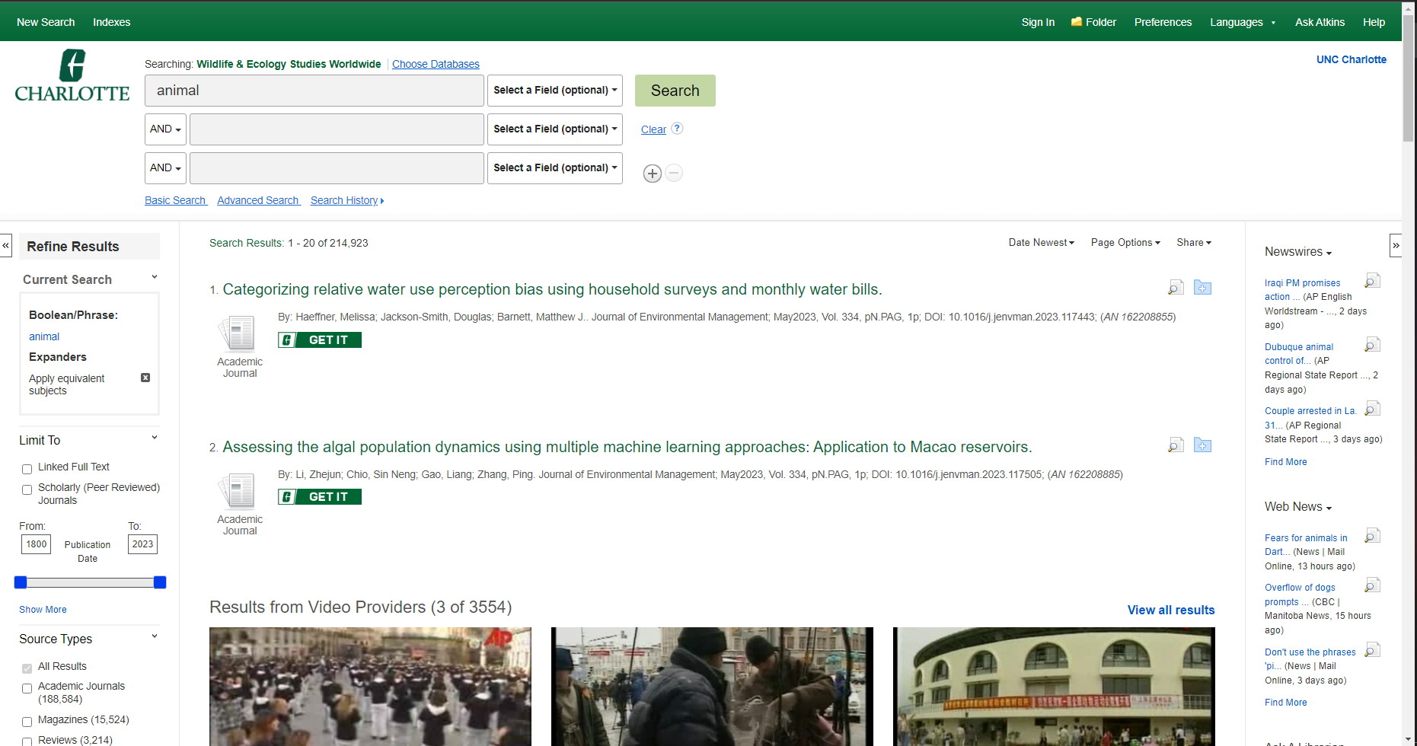

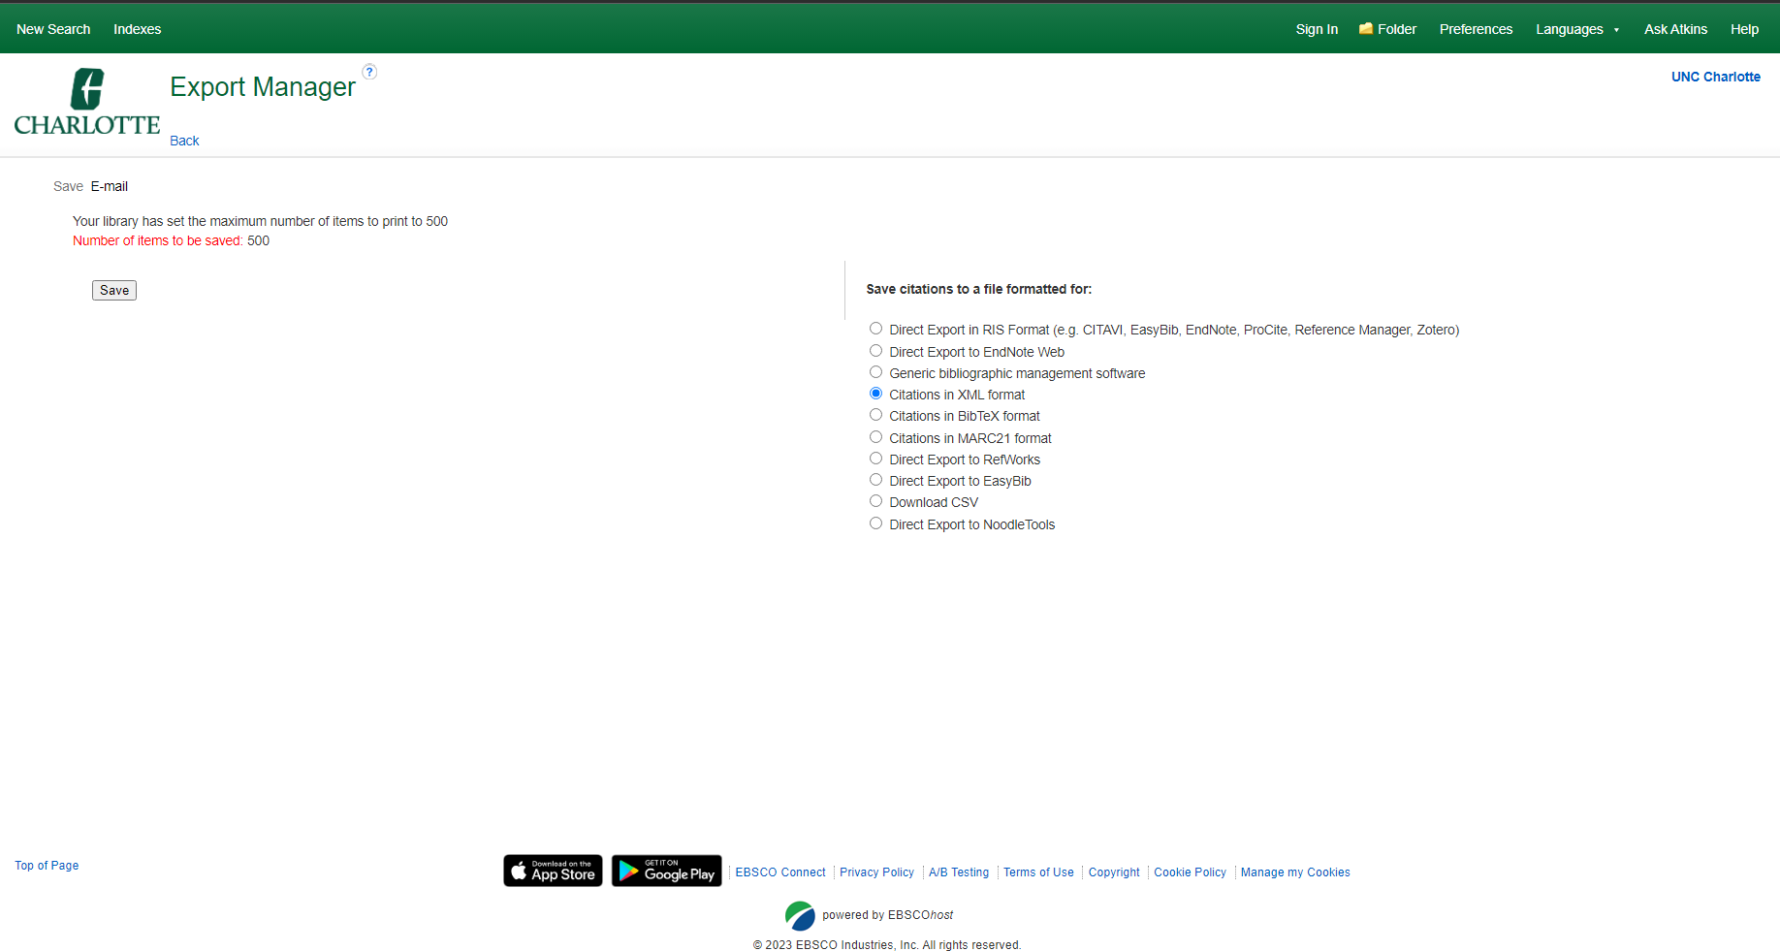

Can be used to export search results in XML format for data input for databases.

More instructions: <http://support.ebsco.com/help/index.php?help_id=1325>

OPTION 4 (data scrape from HTML of online zoo website):

This website provides all the animals from a zoo from your location picking.

view-source:<http://theonlinezoo.com/pages/north_carolina_zoo.html>

<http://theonlinezoo.com/pages/north_carolina_zoo.html>

OPTION 5 (NCBI journal results of animals from a zoo):

<https://pubmed.ncbi.nlm.nih.gov/?term=%22Animals%2C+Zoo%22%5BMesh%5D&size=200>

Press Save ALL RESULTS into a summary text file and we can compare text results to the zoo.

## (summary-AnimalsZoo-set.txt RESULTS FILE IN THE GOOGLE DRIVE)

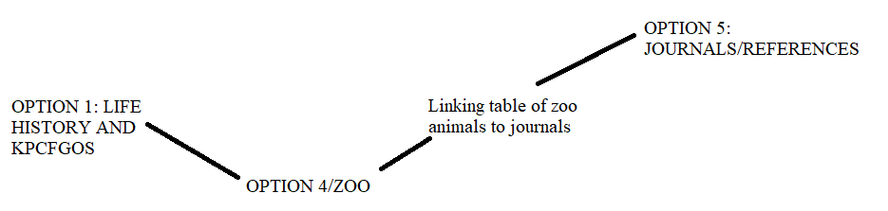

<https://www.ncbi.nlm.nih.gov/gene?term=%22Equus%20quagga%20boehmi%22%20%5BOrganism%5D%20OR%20%22Oxyura%20jamaicensis%22%20%5BOrganism%5D%20OR%20%22Ampeliceps%20coronatus%22%20%5BOrganism%5D%20OR%20%22Naja%20pallida%22%20%5BOrganism%5D%20OR%20%22Basiliscus%20plumifrons%22%20%5BOrganism%5D%20OR%20%22Aythya%20valisineria%22%20%5BOrganism%5D%20OR%20%22Dendrocygna%20bicolor%22%20%5BOrganism%5D%20OR%20%22Macrochelys%20temminckii%22%20%5BOrganism%5D%20OR%20%22Zalophus%20californianus%22%20%5BOrganism%5D%20OR%20%22Anser%20anser%22%20%5BOrganism%5D%20OR%20%22Erythrocebus%20patas%22%20%5BOrganism%5D%20OR%20%22Puma%20concolor%22%20%5BOrganism%5D%20OR%20%22Struthio%20camelus%22%20%5BOrganism%5D%20OR%20%22Phacochoerus%20sp.%22%20%5BOrganism%5D%20OR%20%22Leopardus%20pardalis%22%20%5BOrganism%5D%20OR%20%22Giraffa%20camelopardalis%20reticulata%22%20%5BOrganism%5D%20OR%20%22Trioceros%20melleri%22%20%5BOrganism%5D%20OR%20%22Leptailurus%20serval%22%20%5BOrganism%5D%20OR%20%22Coendou%20prehensilis%22%20%5BOrganism%5D%20OR%20%22Graptemys%20versa%22%20%5BOrganism%5D%20OR%20%22Lachesis%20stenophrys%22%20%5BOrganism%5D%20OR%20%22Bassariscus%20sumichrasti%22%20%5BOrganism%5D%20OR%20%22Python%20regius%22%20%5BOrganism%5D%20OR%20%22Leiothrix%20lutea%22%20%5BOrganism%5D%20OR%20%22Mycteria%20ibis%22%20%5BOrganism%5D%20OR%20%22Amazona%20finschi%22%20%5BOrganism%5D%20OR%20%22Panthera%20leo%22%20%5BOrganism%5D%20OR%20%22Chelonoidis%20carbonarius%22%20%5BOrganism%5D%20OR%20%22Alligator%20mississippiensis%22%20%5BOrganism%5D%20OR%20%22Mareca%20americana%22%20%5BOrganism%5D%20OR%20%22Pituophis%20deppei%22%20%5BOrganism%5D%20OR%20%22Eunectes%20notaeus%22%20%5BOrganism%5D%20OR%20%22Kinosternon%20baurii%22%20%5BOrganism%5D%20OR%20%22Anas%20platyrhynchos%22%20%5BOrganism%5D%20OR%20%22Crotalus%20horridus%20horridus%22%20%5BOrganism%5D%20OR%20%22Ophiophagus%20hannah%22%20%5BOrganism%5D%20OR%20%22Arctictis%20binturong%22%20%5BOrganism%5D%20OR%20%22Sceloporus%20jarrovii%22%20%5BOrganism%5D%20OR%20%22Vulpes%20zerda%22%20%5BOrganism%5D%20OR%20%22Ara%20macao%22%20%5BOrganism%5D%20OR%20%22Vulpes%20lagopus%22%20%5BOrganism%5D%20OR%20%22Cyanoloxia%20cyanoides%22%20%5BOrganism%5D%20OR%20%22Naja%20nigricollis%22%20%5BOrganism%5D%20OR%20%22Crotalus%20willardi%22%20%5BOrganism%5D%20OR%20%22Crotalus%20atrox%22%20%5BOrganism%5D%20OR%20%22Caloenas%20nicobarica%22%20%5BOrganism%5D%20OR%20%22Thalassornis%20leuconotus%22%20%5BOrganism%5D%20OR%20%22Dendrocygna%20autumnalis%22%20%5BOrganism%5D%20OR%20%22Buteo%20swainsoni%22%20%5BOrganism%5D%20OR%20%22Numida%20meleagris%22%20%5BOrganism%5D%20OR%20%22Bothrops%20erythromelas%22%20%5BOrganism%5D%20OR%20%22Aspidelaps%20lubricus%20lubricus%22%20%5BOrganism%5D%20OR%20%22Aethia%20psittacula%22%20%5BOrganism%5D%20OR%20%22Tyrannus%20forficatus%22%20%5BOrganism%5D%20OR%20%22Netta%20erythrophthalma%22%20%5BOrganism%5D%20OR%20%22Antigone%20canadensis%22%20%5BOrganism%5D%20OR%20%22Ursus%20maritimus%22%20%5BOrganism%5D%20OR%20%22Gorilla%20gorilla%20gorilla%22%20%5BOrganism%5D%20OR%20%22Pavo%20cristatus%22%20%5BOrganism%5D%20OR%20%22Antilope%20cervicapra%22%20%5BOrganism%5D%20OR%20%22Bothrops%20moojeni%22%20%5BOrganism%5D%20OR%20%22Papio%20hamadryas%22%20%5BOrganism%5D%20OR%20%22Centrochelys%20sulcata%22%20%5BOrganism%5D%20OR%20%22Giraffa%20camelopardalis%22%20%5BOrganism%5D%20OR%20%22Cygnus%20melanocoryphus%22%20%5BOrganism%5D%20OR%20%22Leucophaeus%20pipixcan%22%20%5BOrganism%5D%20OR%20%22Terathopius%20ecaudatus%22%20%5BOrganism%5D%20OR%20%22Dendroaspis%20angusticeps%22%20%5BOrganism%5D%20OR%20%22Spatula%20clypeata%22%20%5BOrganism%5D%20OR%20%22Passerina%20ciris%22%20%5BOrganism%5D%20OR%20%22Goura%20victoria%22%20%5BOrganism%5D%20OR%20%22Falco%20peregrinus%22%20%5BOrganism%5D%20OR%20%22Dolichotis%20patagonum%22%20%5BOrganism%5D%20OR%20%22Aythya%20americana%22%20%5BOrganism%5D%20OR%20%22Lama%20guanicoe%22%20%5BOrganism%5D%20OR%20%22Dendroaspis%20jamesoni%22%20%5BOrganism%5D%20OR%20%22Lynx%20rufus%22%20%5BOrganism%5D%20OR%20%22Chrysocyon%20brachyurus%22%20%5BOrganism%5D%20OR%20%22Crotalus%20molossus%22%20%5BOrganism%5D%20OR%20%22Camelus%20dromedarius%22%20%5BOrganism%5D%20OR%20%22Iguana%20iguana%22%20%5BOrganism%5D%20OR%20%22Ictinia%20mississippiensis%22%20%5BOrganism%5D%20OR%20%22Python%20sebae%22%20%5BOrganism%5D%20OR%20%22Phoenicopterus%20ruber%22%20%5BOrganism%5D%20OR%20%22Panthera%20tigris%20tigris%22%20%5BOrganism%5D%20OR%20%22Bitis%20rhinoceros%22%20%5BOrganism%5D%20OR%20%22Gekko%20gecko%22%20%5BOrganism%5D%20OR%20%22Rhea%20americana%22%20%5BOrganism%5D%20OR%20%22Streptopelia%20capicola%22%20%5BOrganism%5D%20OR%20%22Kobus%20ellipsiprymnus%22%20%5BOrganism%5D%20OR%20%22Chauna%20torquata%22%20%5BOrganism%5D%20OR%20%22Pan%20troglodytes%22%20%5BOrganism%5D%20OR%20%22Anas%20hottentota%22%20%5BOrganism%5D%20OR%20%22Aix%20sponsa%22%20%5BOrganism%5D%20OR%20%22Ovis%20aries%22%20%5BOrganism%5D%20OR%20%22Boiga%20dendrophila%22%20%5BOrganism%5D%20OR%20%22Capra%20hircus%22%20%5BOrganism%5D%20OR%20%22Heloderma%20horridum%22%20%5BOrganism%5D%20OR%20%22Panthera%20tigris%22%20%5BOrganism%5D%20OR%20%22Desmodus%20rotundus%22%20%5BOrganism%5D%20OR%20%22Lama%20glama%22%20%5BOrganism%5D&cmd=DetailsSearch> NCBI GENES RESULT

## Question 1 (25pts).

Describe why your original database is needed, who would use the database, and for what purposes. Be specific, avoid generic databases and the databases that already exist. Your answer will be evaluated based on whether the database and its usage make sense.

Our original database would include the sequencing of a zoo with the related literature that is stored about each zoo animal. The sequencing of the animals that reside inside of the zoo allows the researchers access to valuable data that can be used by the likes of veterinarians and students. Having the ability and understanding of the inner workings of the zoo animals is key for many reasons including understanding future outbreaks (like we experienced with covid), understanding the genetic underpinnings of an organism’s traits and its interaction within a simulated ecosystem. This could be expanded upon in the future if another outbreak happens or what kinds of animals are susceptible to new arising illnesses and developing more robust/data about animals as an open source project. This database bridges the gap from the resource information to each zoo animal. Out of these combinations of resource information we can allow access from broad to more niche information about each animal that is available.

## Question 2 (25pts).

Plot the conceptual model of your database. You can use any style and show the entities and their relationships. No attributes are required at this point.

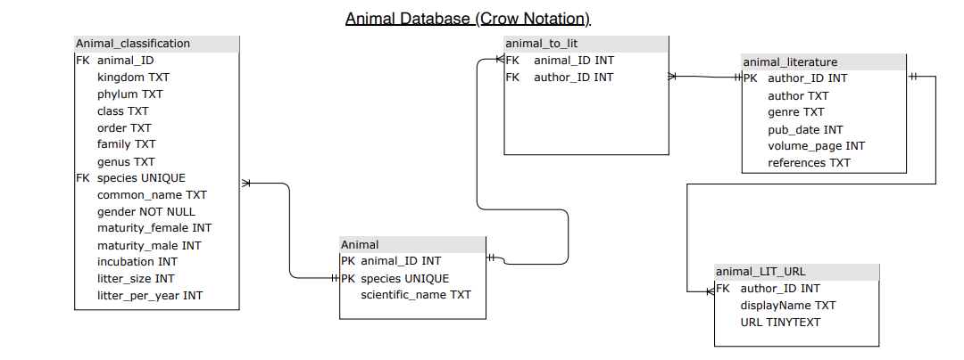

## 

## Question 3 (25pts).

Identify existing resources that can provide data for your project. Describe how you will populate your original database. This will involve looking up some papers and/or existing databases. Make sure that you’ll be able to populate your database in a reasonable amount of time (by the end of semester or earlier)!

NCBI journal results of animals from a zoo (emailed results can be filtered for data entry):

<https://pubmed.ncbi.nlm.nih.gov/?term=%22Animals%2C+Zoo%22%5BMesh%5D&size=200>

Data scrape from HTML of online zoo website:

This website provides all the animals from a zoo from your location picking.

View-source can be used to populate the database:<http://theonlinezoo.com/pages/north_carolina_zoo.html>

Animal classification and test life span information:

<https://genomics.senescence.info/species/index.html>: animal aging and life history website

<https://genomics.senescence.info/species/dataset.zip>: Dataset from website to be entered into our database.

## Question 4 (25pts).

List severalscientific questions that people will be able to answer with the help of your database.

Researchers will be able to have access to the most relevant information regarding the specifics of an animal with distinct differences down to the different types of species. The information included is like the period of maturity, incubation, litter/clutch amount produced and much more. This information is important because it allows more continuity for an animal database. From our own research we found incomplete or limited information in regards to a database for most animals. The information that was found was mostly specific to certain animals or endangered animals. Allowing it being open source can increase continuity from students, researchers and medical professionals alike.

The database will also include scientific studies and research papers that are supported by and are linked to other information that can be useful for the spectrum of users. For example, AnAge could be linked to the available genetic information for specific species of a zoo. And based on our own research, finding both databases and research papers on animals was difficult without having to run into some data that was from non reputable sources “.org” and blog-like websites.